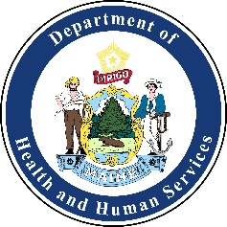
Healthcare Coalition of Northern Maine Meeting Agenda
Wednesday, April 8, 2020 9:00 am - 10:30 am
Location  Virtual Meeting |  | Attend Virtually  https://zoom.us/meeting/register/tJQocOigqjoq8EUIz9Wh0Q4yUvLOSAmmpg  Phone: 646-558-8656  Meeting ID: 905-718-410
Time: | Activity: | Action: | Attachment: (Yes/No) | Person Responsible:
9:00am | Call to Order | Declaration | No | Megan Melville
9:00am | Welcome | Introductions | No | Megan Melville
9:00am-9:15am | Round Table:  - Lessons learned from recent exercises or incidents  - Survey lessons learned  - Upcoming trainings or exercises | Discussion | No | All
9:15am | Agenda | Amend | Yes | Megan Melville
9:15am | Approval of March Meeting Minutes | Vote | No | Megan Melville
9:15am-10:15am | NIMS Workshop | Presentation | No | Mike Hatch
10:15am-10:30am | Coalition News:  - Focus Groups | Update | No | Mike Hatch
 | - Meet and Greet | Informational | No | Megan Melville
 | - COVID-19 | Discussion | No | All
 | - Training, Conferences, Webinars, and Exercise Opportunities | Informational | No | All
 | - Useful Links | Informational | No | All
10:30am | Meeting Evaluation and Adjourn | Adjourn | Yes | All

NEXT MEETING:
Wednesday, May 13, 2020
9:00am to 12:00pm
Virtual Meeting via Zoom

