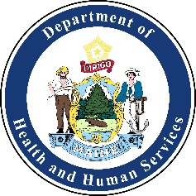
Healthcare Coalition of Southern Maine Meeting Agenda
Friday, April 24th, 2020 from 9:00am-10:30am
Virtually Meeting Only:
https://zoom.us/j/803728790
Dial: 646 558 8656
Meeting ID: 803 728 790
Time: | Activity: | Action: | Attachment: (Yes/No) | Person Responsible:
09:00am | Welcome | Introductions | No | Allyssa Caron
09:00am-09:10am | Introductions:  - Name/position/title  - Facility/organization name  - Lessons learned, upcoming training and exercises | Discussion | No | All
09:10am-10:15am | COVID-19 Simulation Exercise | Workshop | No | All
10:15am-10:30am | Coalition Updates & Action Items | Discussion | No | Allyssa Caron
10:30am | Meeting Evaluation and Adjourn | Adjourn | No | Allyssa Caron

NEXT MEETING:
Friday May 29th
Time & Location: TBD

