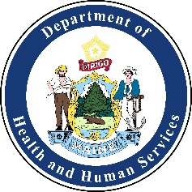
Healthcare Coalition of Southern Maine Meeting Agenda
Friday, May 29th, 2020 from 9:00am-10:30am
Virtually Meeting Only:
https://zoom.us/j/467548418
Dial: 646 558 8656
Meeting ID: 467 548 418
Time: | Activity: | Action: | Attachment: (Yes/No) | Person Responsible:
09:00am | Welcome | Introductions | No | Allyssa Caron
09:00am-09:10am | Introductions:  - Name/position/title  - Facility/organization name  - Lessons learned, upcoming training and exercises | Discussion | No | All
09:10am-09:20am | COVID-19 Updates/Resources | Discussion | No | Allyssa Caron
09:20am-10:00am | COVID-19 After Action Report (AAR) Preparation | Workshop | No | Allyssa Caron
10:00am-10:30am | Open Discussion: COVID-19 Organization Updates or Questions | Discussion | No | All
10:30am | Meeting Evaluation and Adjourn | Adjourn | No | Allyssa Caron

NEXT MEETING:
Friday June 26th
Time & Location: TBD

